National Environment Science Camp II
, ,.

The Wonderful Web of Our Life

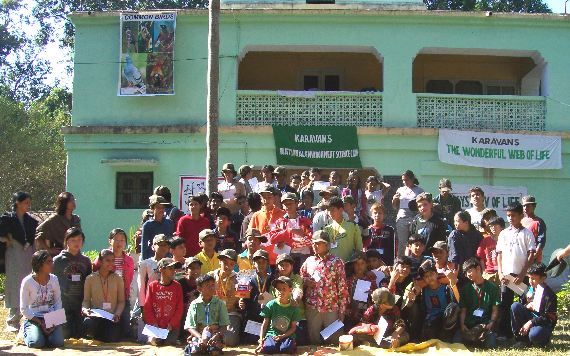

Karavan Heritage and Nature Society,
40, Usman Enclave, Aliganj Extension. Lucknow, UttarPradesh, India-226024,
Contact: 91-0-9839073822 / 91-0-9451175539, email:karavanlko@gmail.com
Website: www.dudhwanationalpark.org / www.karavanindia.org

The Resounding Success of the National Environment Science Camp-I inspired Karavan Heritage and Nature Society to once again organize the National Environment Science Camp-II at Dudhwa National Park in the Himalayan Terai, in the month of November-December 2007-January 2008. The theme of this Camp was:
‘THE WONDERFUL WEB OF OUR LIFE.’
This Camp was an exploration of the inanimate entities that sustain life, the myriads of life-forms and their interdependence for survival. The participants gained an insightful knowledge about the Web of our Life through a host of activities.

And these few pages attempt to scribble the experiences of the participants and relive the Camp for those who could not make it to this lifetime event.

Day1
First day we attempted to orient the participants to the National Environment Science Camp and Dudhwa National Park.

The participants were divided in groups, they gave interesting names to their groups and then on participated in all the activities as a part of their groups.

The Theme of the day was ‘The Mystery of Life’

‘The Green Creed from Dehradun’ described their experiences as follows:

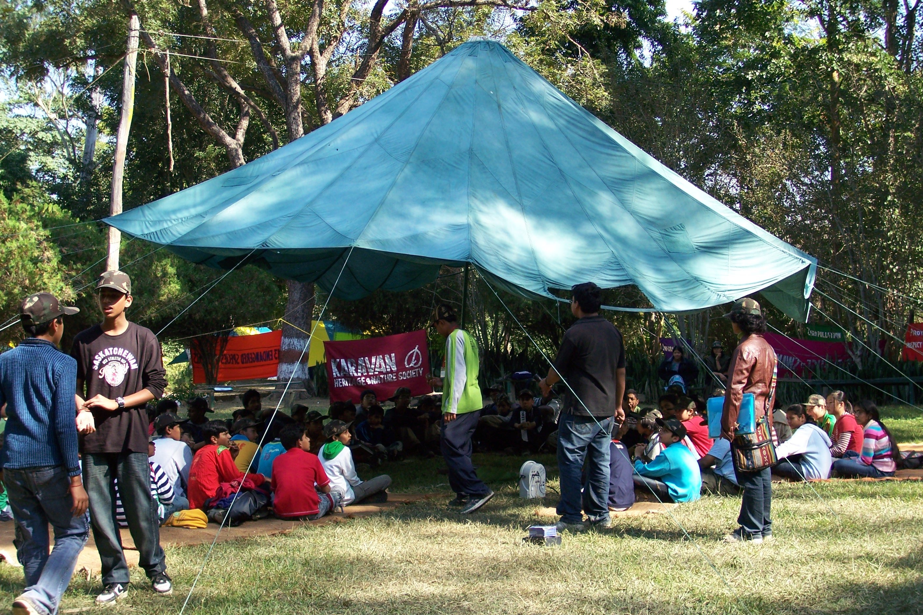
“It was a pleasure for us to attend the National Environment Science Camp. As we approached the camp site we were more and more curious. The Camp organizers gave us a warm welcome. After taking some rest, we had a great lunch, amidst the lap of nature. Then the organizers briefed us about the camp. Full of enthusiasm, we welcome the other school, who arrived somewhat late. These guys were great competitors and were very eco-friendly. Entertaining games soon followed, which we enjoyed thoroughly. We, then, went on a night walk in the woods. It was really adventurous. We heard various sounds and howls from all over the jungle. We thus, successfully accomplished the tasks given to us today”

‘The Wild Cats’ from Bangalore. had this to say:
“Arrival : 1:30 PM, We were led into the campsite by our Camp Leader Deepti, The other group welcomed us by clapping as we entered.
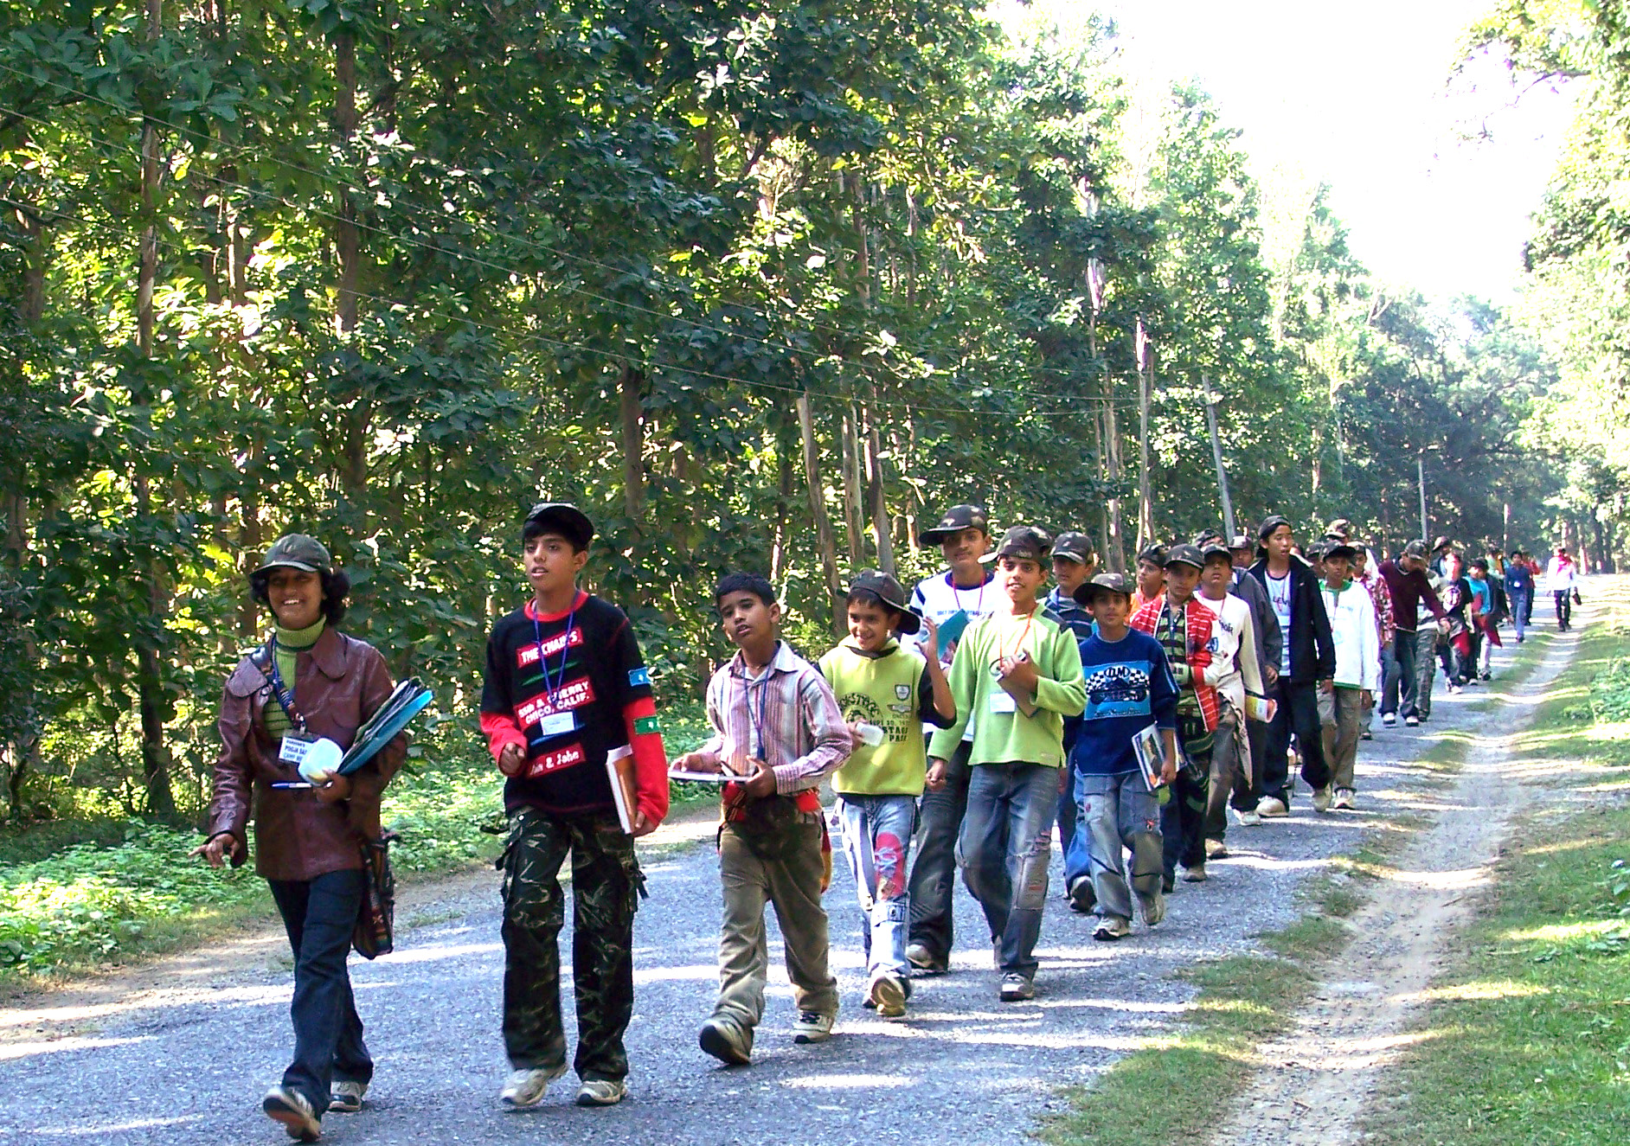
3:30PM: We were briefed about the camp. An activity called ‘The Mystery of Life’ followed. Here we un jumbled the ‘Ingredients of Life’ we had to collect these ingredients in a test tube.

‘The Tree of Life’ was then explained to us.
4:30 PM: Our next activity was the ‘Flame of Life’ 1st, we made a torch of life, then we had to guess the Life span of an Animal Species and finally run a relay by passing the torch of life to the other members of our group.

6:30 PM Our last activity for the day was ‘Survival of the fittest’, our group was separated from rest of the groups and we entered the Jungle with the Moonlight illuminating our way, during the walk we saw an Ant Hill between two huge trees. We latter switched off our torches and stood still for 10-15 min. We heard the Jackals calls ringing through the forest and the birds chirping

around us, it was an amazing experience. More such experiences would be delightful.”

Day 2:
This day was full of activity, the theme of the day was ‘The Diversity of Life’

The Prithvi Group from Dehradun beautifully described their experiences on the second day
“ Early to bed, early to rise, makes a man healthy , wealthy and wise. As we got up quite early, we saw the beautiful night sky. The Sun had not yet risen and stars were still twinkling.
After the morning Tea, we exercised to stay fit through out the day. After the breakfast we solved the Pangea puzzle, where we linked the segments of the super continent which were attached together about 2 billion years ago. After wards all the participants became different Scientists of different fields. And started observing the plants, animals, birds etc. we went to the grasslands and the wetlands. We found many birds of different colors: yellow, orange, grey, brown. We also found different types of insects: Grasshopper, Ladybirds, Crickets etc. we collected Soil samples that were loamy and sandy.
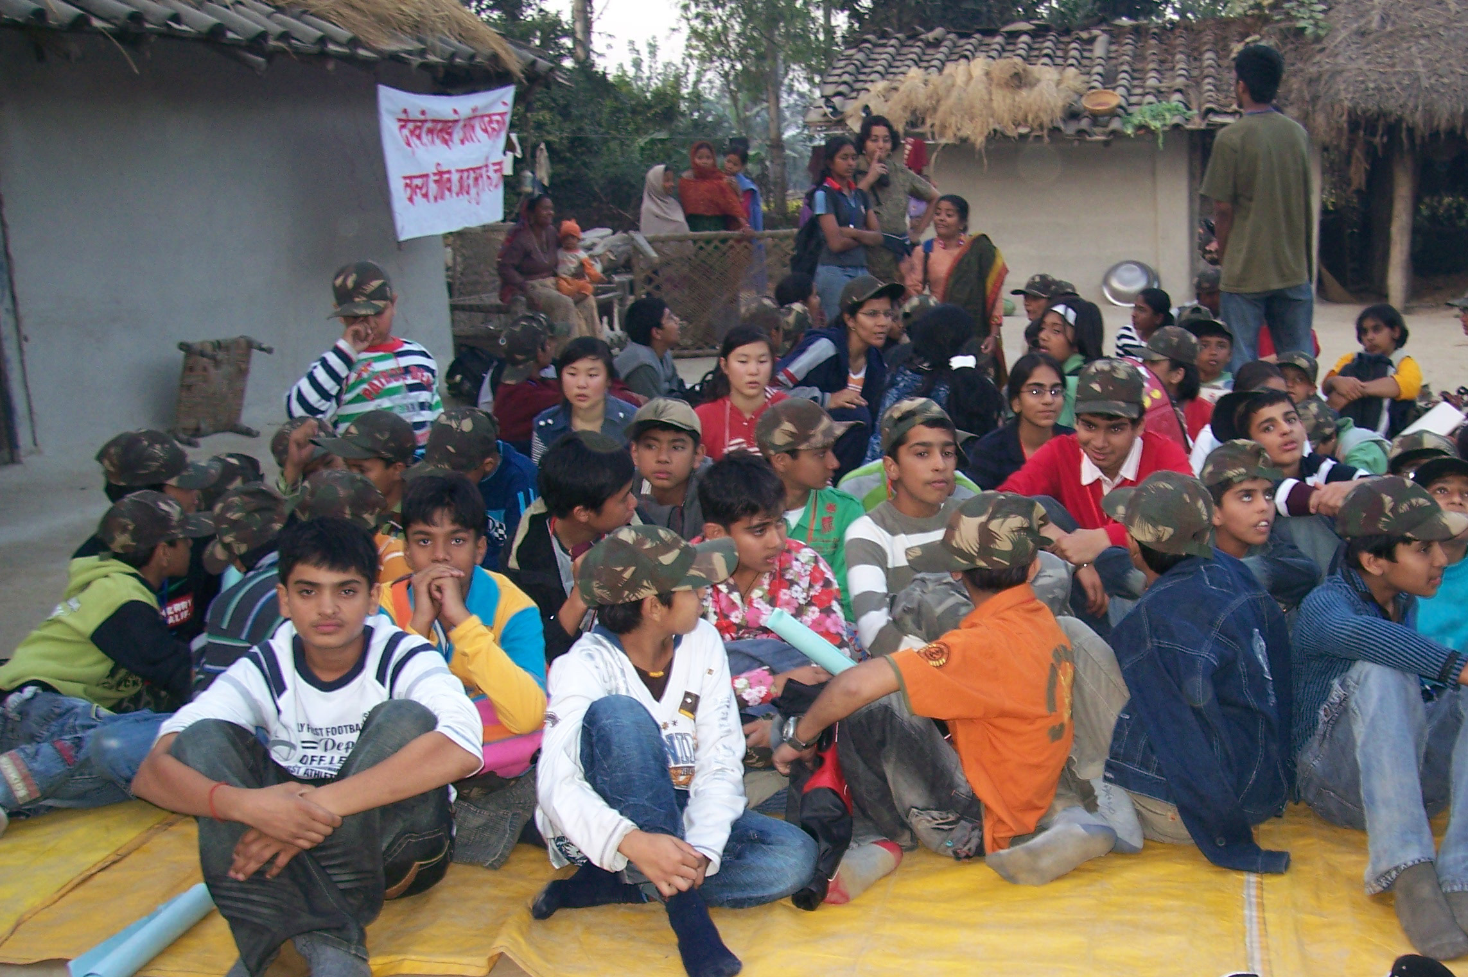
After Lunch we went to the Mohana river on the Indo-Nepal Border. We next went to the Tharu village. We saw the houses of the people living in the village. The entire house was made of mud. The speciality of the house is such that it is warm in the winters and cool in the summer season. We enacted a skit for the Tharus. Our message was that we should treat the animals with kindness and should not cut trees.
Finally after Dinner each participating group was tasked to perform the characteristics of certain animals. For example one group enacted the Peacocks, cat walking in a fashion show. Then there were monkeys trying to make others laugh, we had Tigers dancing and Sal trees showing there strength. We had a great time and wished good luck to each other.”

Forest Rangers from Kanpur

“There was an early wake up call at 4:30 AM sharp. It was a chilly morning. And we were shivering. But, still, we ventured for exercises; and enjoyed every moment of it. The forest behind the Campsite with the huge trees looked both scary and beautiful. After a wonderful breakfast, each participant set out for ‘Forest Census’ the Woodlands, Wetlands and Grasslands as a scientist. In our group, we had Botanists, Geologists, Zoologists and Ornithologists. We had our Discovery Table with us for the observations. The botanists collected different herbs, grasses and leaves; the soil was identified by color and texture; the animals, birds and insects were observed by their color, tail, dung, legs, eyes, body etc. We had a great time! We never thought science could be so interesting. After that we were provided with mouth watering delicacies for lunch.
We later went to see the river Mohana that forms the Indo-Nepal border. We also visited a village inhabited the Tharu Tribal community. These people are originally from Rajasthan and have been living in Dudhwa since long. We enacted a skit for the Tharus and tried to convey the message of conservation.

Later during the Campfire, the ‘Greatest Indian Idol Contest’ was a smashing hit. All the groups gave a fantastic performance on the antics of the different animals and birds of Dudhwa.”

Day3
By now the participants were in the groove of National Environment Science Camp.
It was easy to wake them up so early, and we all moved on to explore the ‘Interdependence of Life’: the theme of the day in the tourist zone of Dudhwa.
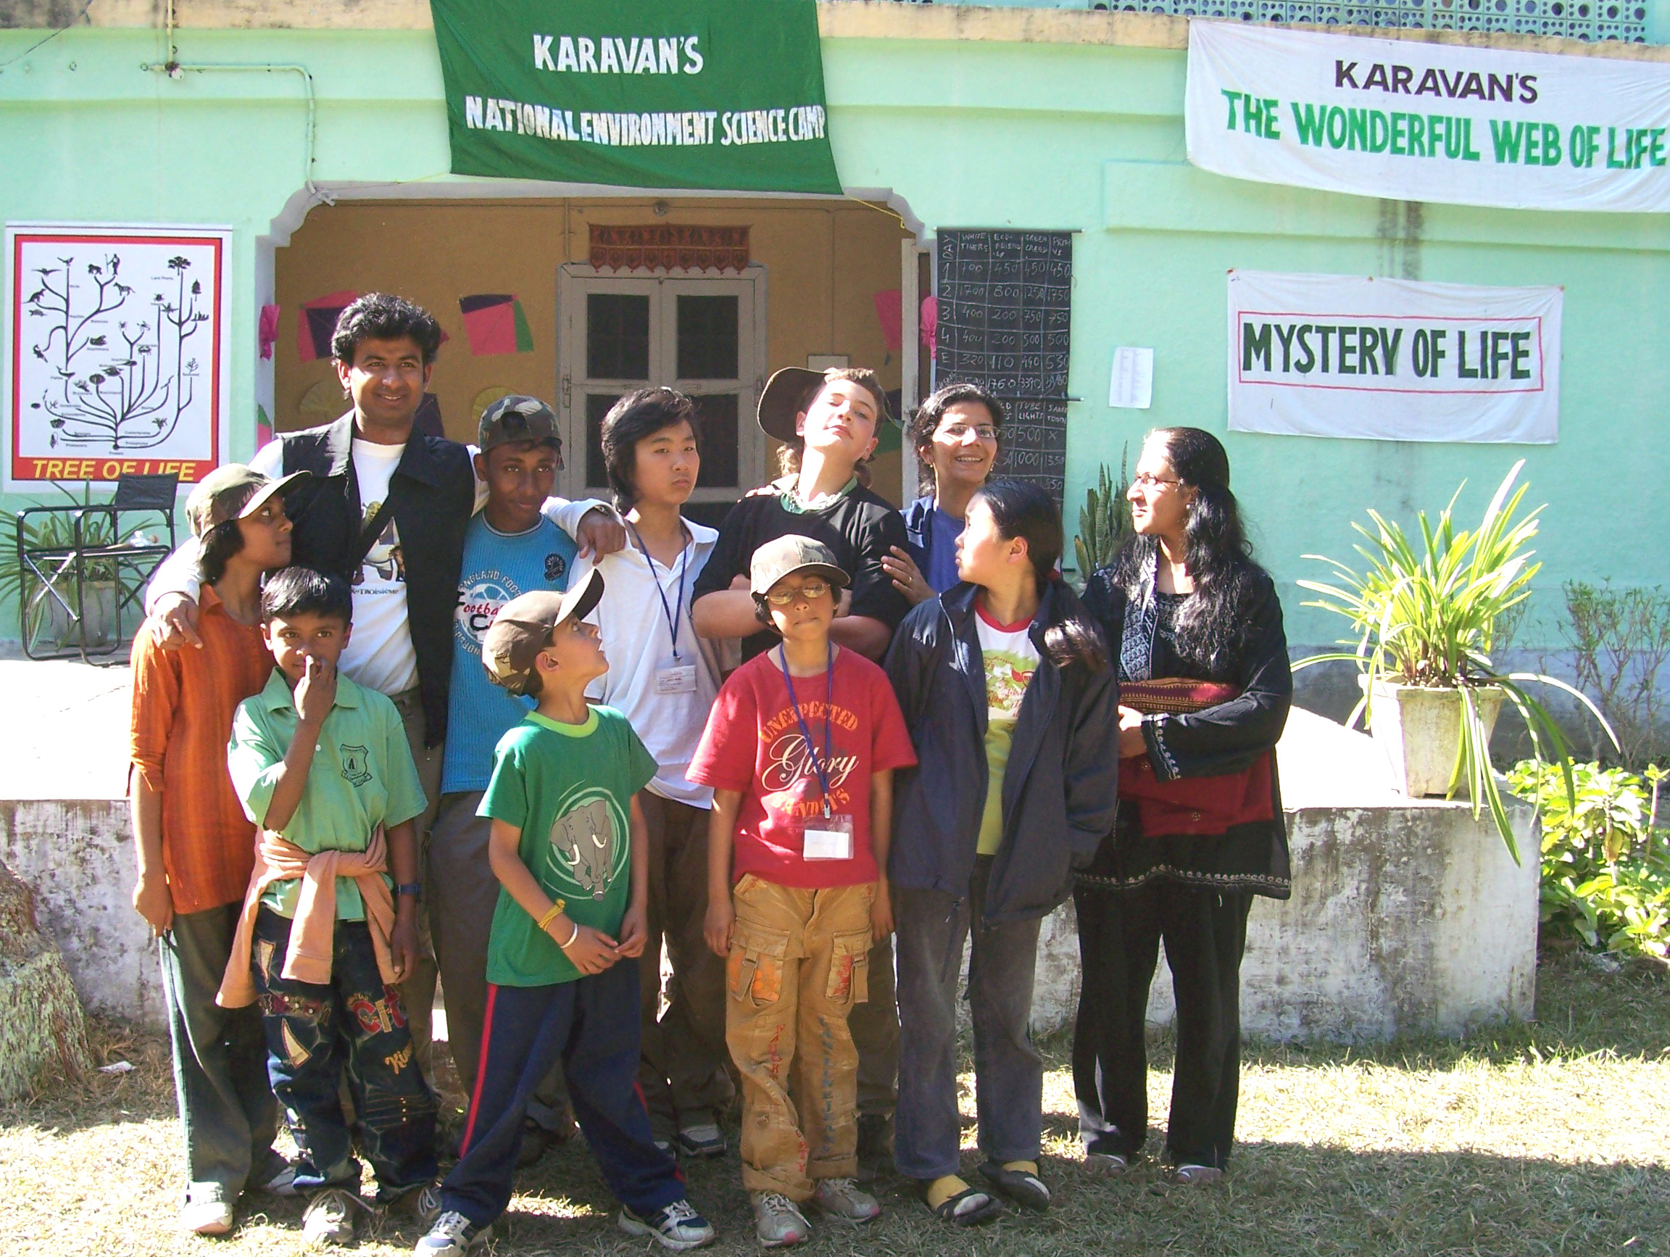
Saber Tooths from Ooty report
“ We got to refresh our knowledge on Food web and we pretty much got aware of the condition of the forest. We also learned different ways of marking territory of certain animals. A Tiger leaves a big Scary Scratch on a tree trunk. And the Rhinos do their jobs on one spot. All the Rhions come to a spot and there are heaps of Rhino Dung. But because of this, it is very easy for the poachers to hunt them. In Dudhwa the Rhinos are protected in an area of approx 27 sq km.”

Pouncing Tigers from Bareilly
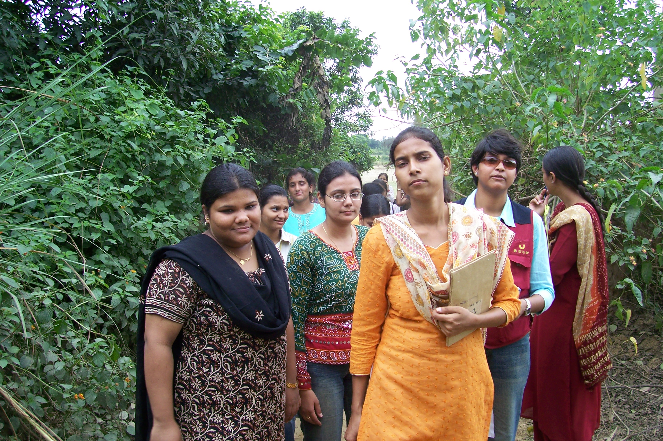
“The third day brought a lot of happiness for us. We got up early. Had our breakfast and went to the Tourist Zone. We saw the pug-marks of a tiger, wild boars, swamp deer and a crocodile basking near the Suheli river. We also got to see many kinds of birds like the Peacocks, Jungle Fowls, Parakeets, Drongos and Partridges. We reached Salukapur and from there we went for an Elephant Ride. The Elephant walked inside the Rhino area. We were amazed to see the Rhinoceros and her calf at very close quarters. Rhinos have good smelling and hearing power but have poor eyesight.”
Deepti, the camp leader reports on the encounter with a Rhinoceros at Dudhwa
“I was standing on the dirt track in Dudhwa Tourist Zone with around 20 young participants. We were anxiously awaiting our turn for the Elephant ride, to sight the Rhinos in the grasslands.
When suddenly, I noticed an odd movement on the track and lo; to my surprise and horror a mother Rhino, with her calf in tow was advancing towards us. She was just around 200 meters away. The participants had also noticed the Rhino and her Calf and were terribly excited but I was really worried; a female Rhino with her calf is one of the most lethal creature to encounter in the wild. I gestured the students to keep their excitement under control. And we awaited with bated breath. She was moving lazily towards us, stopping to graze and sniffing the air by twitching her moist nostrils. The calf swayed side by side as though drunk. And we all watched anxiously. The Rhino marched a 100meters further ahead towards us and then to our great relief slithered inside the forest. We could still see her tail moving in between the trees. I, then heaved a sigh of relief.”

DAY 4:
Green Revolutionaries from Lucknow
“As compared to the other days, the mood was quite relaxed today. We awoke late (5:30 AM)! had tea and rushed out for the delightful games being organized by our mentors. We played kabbadi and kho-kho with the other teams. With the kind of competition, it was tough leaving the field. We finally had our breakfast at 8:30 A.M. We were then told about the Conservation Work to be undertaken at the Campsite. So, we picked up the equipments and set out to clear the weeds and beautify the Campsite. It was an enjoyable exercise.”
SCOPE
This is what Ms. Archana Neginhal, Principal Blue Mountain School Ooty writes:

“The Wonderful Web of Life says it all; for this Camp introduced us to the Complex Web of Nature/ Education/Relationships-Life indeed. The Karavan Team had created a program that challenged young minds. The modules and activities were based on thinking skills and expected learning outcomes were:
-ability to respond
-work as a team and present observations
-making connections and internalizing concepts.
Fortunately, I must say, they were not ability to reproduce facts and figures or textual matter.
Well organized, well planned, yet open ended in terms of structure! I feel it was a great success.”

EXPERTS

“Our children enjoyed themselves completely and learnt a lot. They are full of appreciation for the Camp Mentors: Mr. Rohit and Ms. Pooja, who virtually became one of them and stood by them throughout. These words of Raghav, a Class Fifth student, would be enough to understand their feelings, “Madam,” (he asked me) “can you not tear our tickets so that we don’t have to go back!” Ms. Shalini Sharma Teacher Coordinator Sela Qui World School, Dehradoon

“The Camp Mentors are efficient, punctual, caring and knowledgeable in matters pertaining to the Eco-systems as well as the rural areas. The program was meticulously executed. The entire department is grateful for their hospitality and care.” Dr. (Mrs). J.S. Simlai, Dept of Geography, Isabella Thoburn College, Lucknow.

ACCOMODATION, ARRANGEMENTS AND LOGISTICS
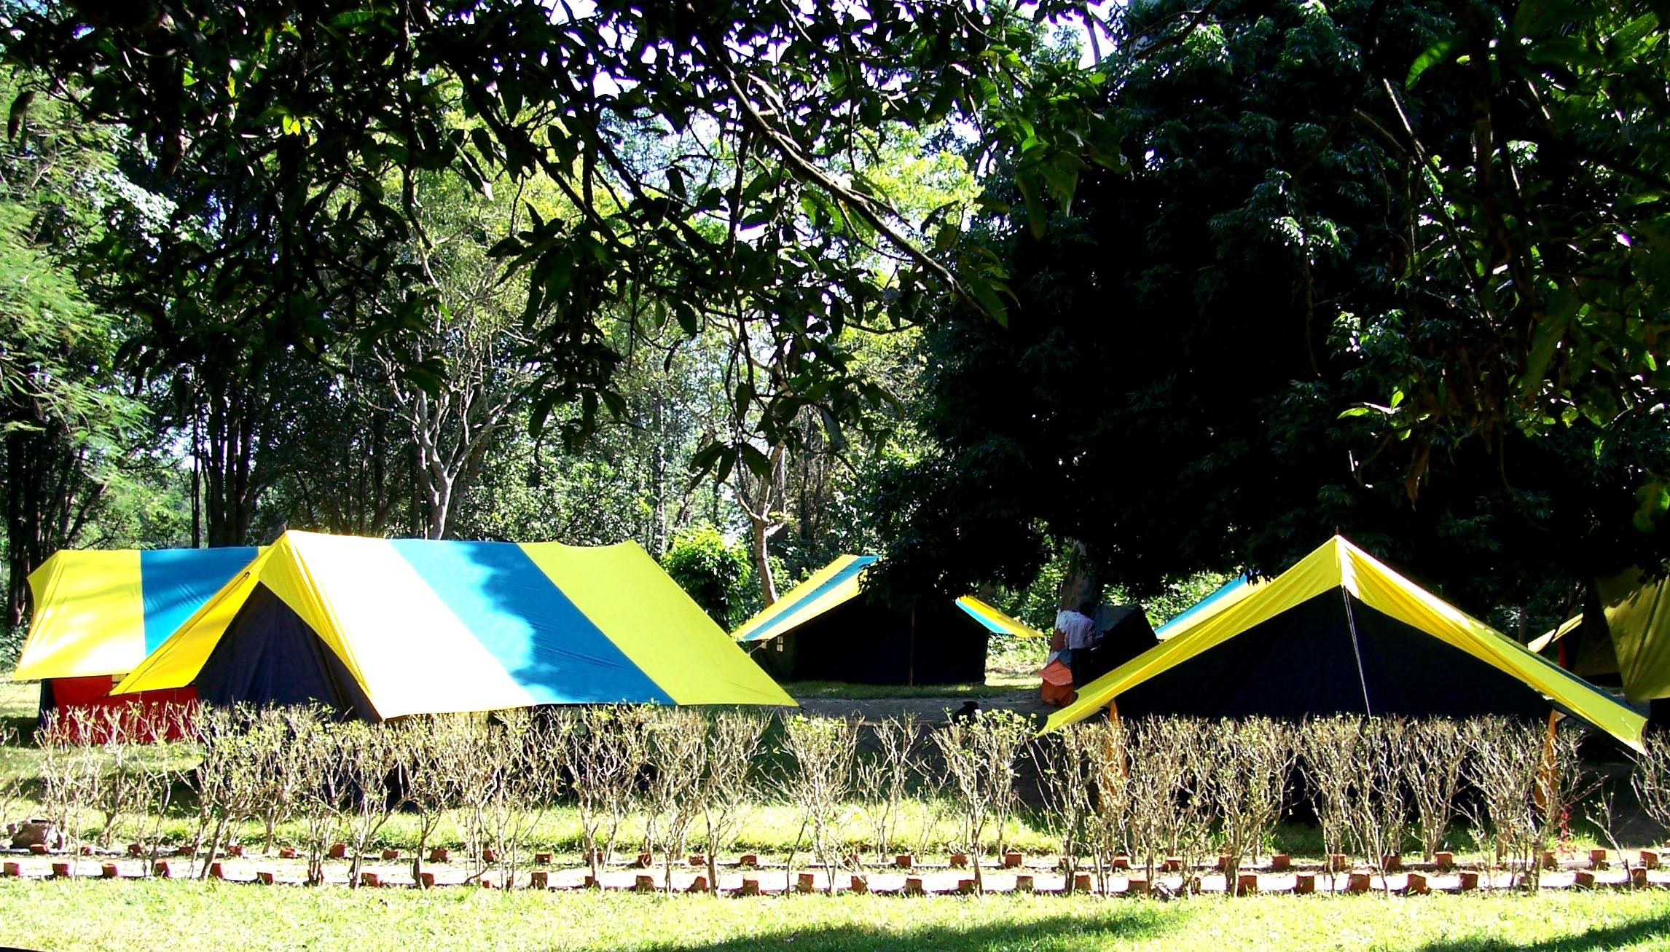
“Camp site was good and the alpine tents were very good and cozy; my students were more than satisfied. Dry pit Toilets were an experience in itself for the students. Teacher’s accommodation was perfect”: Mr. Ashwin Kr. Gite, Sela Qui World School, Dehradun.

“I really appreciate the hard working, lovable, co-operative and homely attitude of the Karavan Team. The experiences in the Camp will always be a memorable treasure for us. I would like to thank one and all for providing best food: palatable, delicious and numerous varieties.” Ms Deepa Garg Teacher Coordinaor,Bhartiya Vidya Bhawan, Bareily
SUMMARY
“We thank the entire team of Karavan for this wonderful experience of Dudhwa. The attention paid to every detail of organizing the Camp as well as the warm hospitality extended by your entire team was truly remarkable and will sty with us. The spirit with which the Camp was organized and the commitment of the team for our precious natural environment is what we are taking back with us. This exposure to Dudhwa and its abundant bounty has expanded our consciousness and awareness with regard to the environment. We go back with the hope that we will take it forward in our own way”. PRAKRIYA: THE GREEN WISDOM SCHOOL COMMUNITY, BANGLORE.

